Pizza Sales Analysis by MYSQL

- Database and its tables:
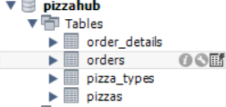

Basic level

- Total number of order placed in the pizzahub shop
(21350)
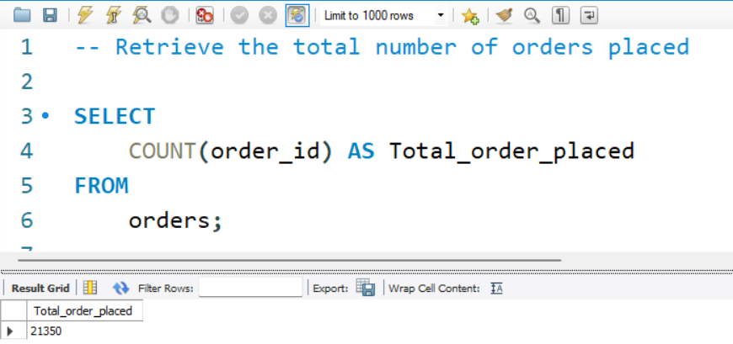

- Total revenue generated from the pizza sales in shop (817860)

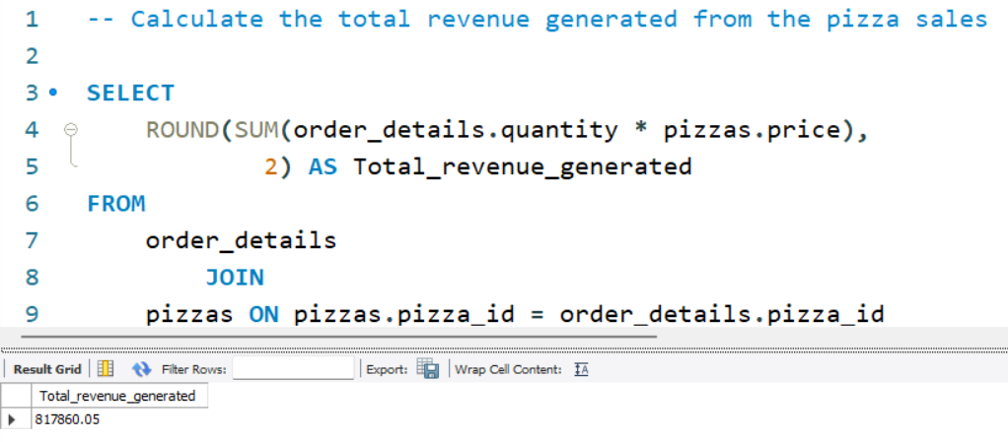

- Highest priced pizza (Greek pizza - $35.95)

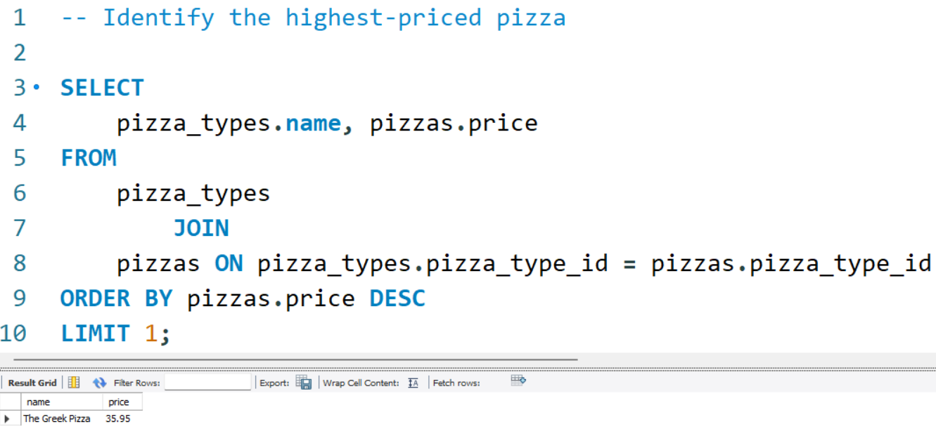

- The most common pizza size ordered is Large with 18526 orders.

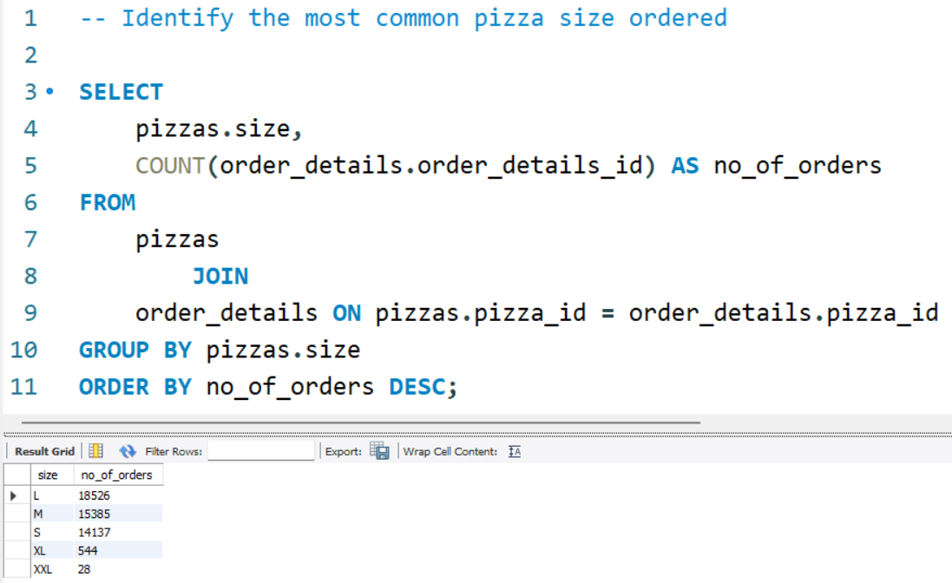

- Top 5 most ordered pizza types along with their quantities
(Classic Deluxe pizza - 2453 [Highest ordered]
Barbecue chicken pizza - 2432
Hawaiian pizza - 2422
Pepperoni pizza - 2418
Thai chicken pizza - 2371)

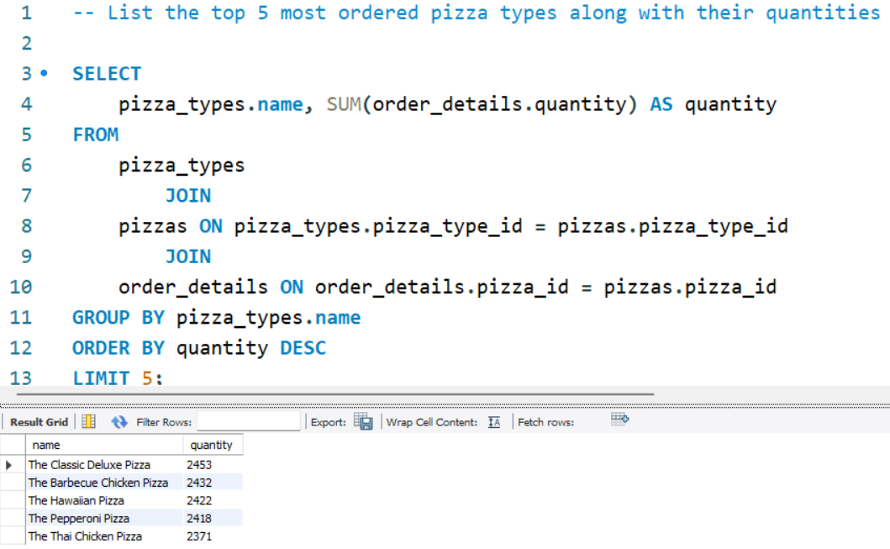

Intermediate level

- Join the necessary tables to find the total quantity of each pizza category ordered
[Classic pizza is ordered maximum times with the quantity of 14888 pizzas]

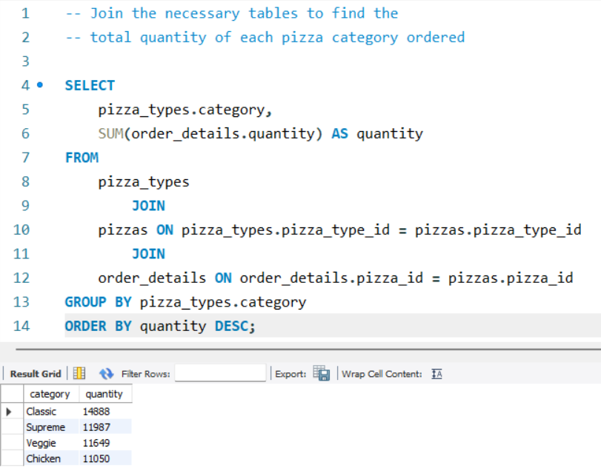

- Determine the distribution of orders by hour of the day
[Maximum orders were taken at 12 O’ clock(noon) with the count of 2520 orders]
[Busiest hours(estimated time)-from 12 noon to 8 evening]

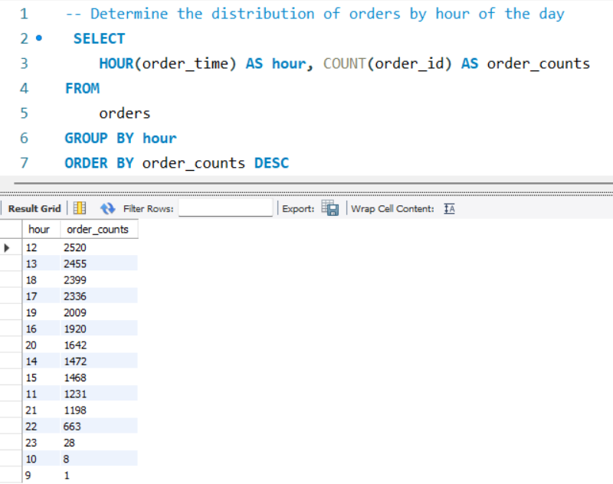

- Join relevant tables to find the category-wise distribution of pizzas
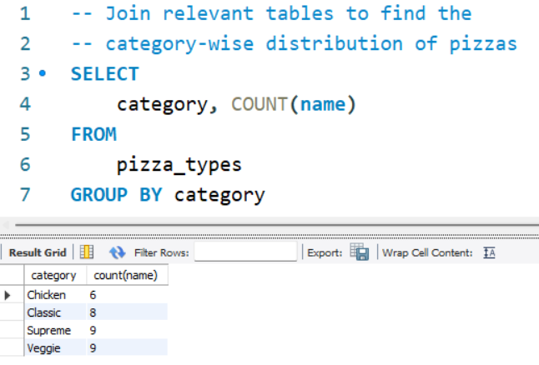

- Group the orders by date and calculate the average number of pizzas ordered per day
[On an average 138 orders are placed per day]

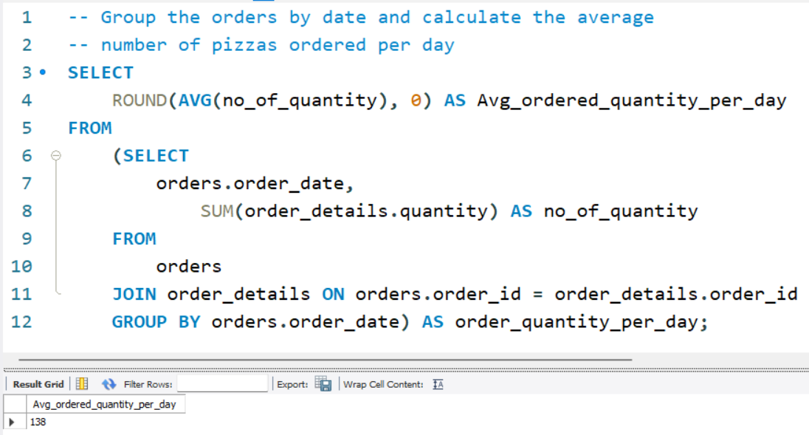

- Determine the top 3 ordered pizza types on revenue
[Out of these 3 pizzas, Thai chicken pizza is generating highest revenue ,i.e, $43434.25]

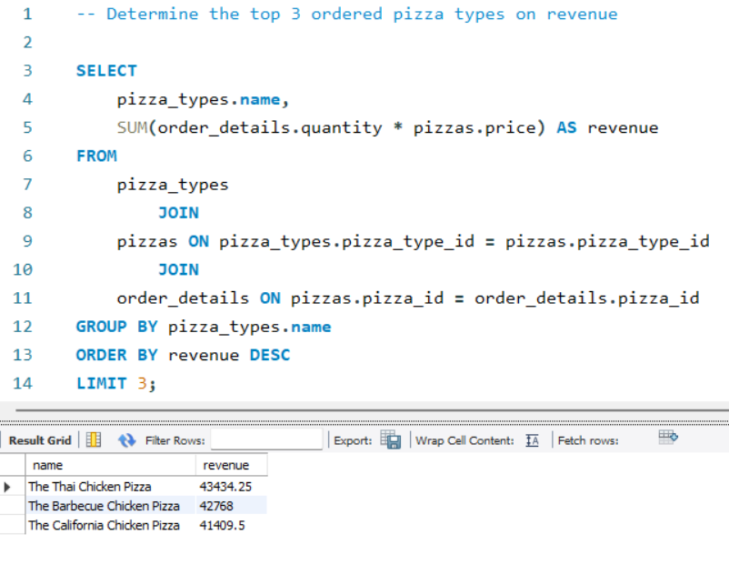

Advanced level

- Calculate the percentage contribution of each pizza type to total revenue
[Most revenue is generated by classic type pizza with the revenue of 26.91%]

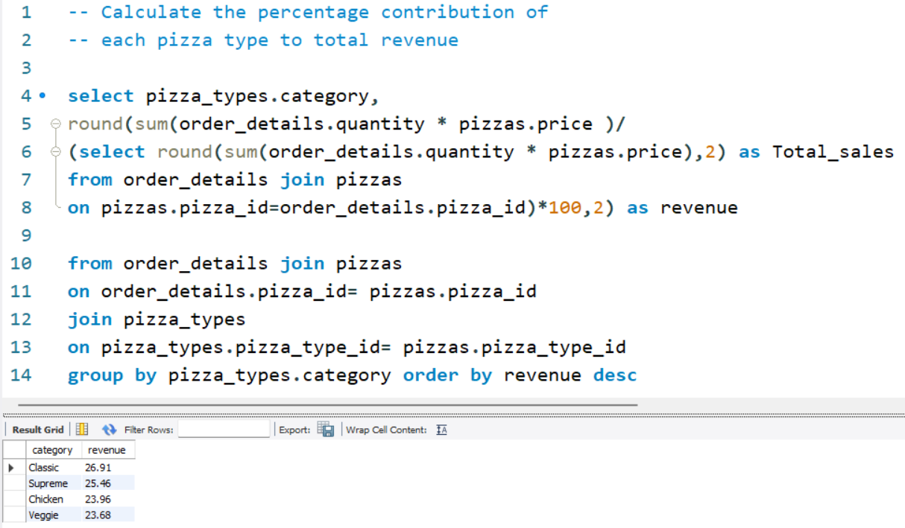

- Analyse the cumulative revenue generated over time

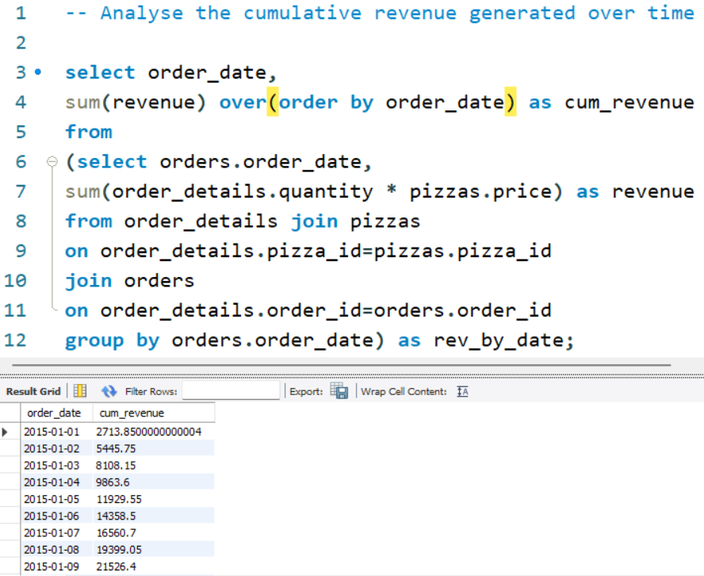

- Determine the top 3 most ordered pizza types based on revenue for each pizza category

